SIMATS ENGINEERING (SAVEETHA SCHOOL OF ENGINEERING)
Department of Computer Science and Engineering
CO3 ASSESSMENT TOOL 2 – Code Review & Repository Evaluation

Course Code: | CSA10 / CSA1063 | Course Title: | Software Engineering
CO Assessed: | CO3 | Assessment: | Assessment Tool 1 – Code Review & Repository Evaluation
Weightage: | 20% | Total Marks: | 25
CO3 Statement: | Build full-stack applications with an emphasis on containerization, version control, and collaborative development
Student Name: | Keerthana.G | Reg. No.: | 192521446
Date: |  | Duration: | 60 minutes

Code of Conduct
I __________________________ (Name / Reg No) certify that this submission is my original work and that I have adhered to the guidelines specified for this assessment. I understand that any violation of academic integrity rules will result in disciplinary action.
Signature of the Student: _________________________

Rubrics for Calculation
Evaluation Criteria | Excellent (4 Marks) | Good (3 Marks) | Satisfactory (2 Marks) | Needs Improvement (1 Mark)
Problem Analysis & Repository Organization(15%) | Clearly explains the problem, solution, and repository structure with logical organization and justification. | Good explanation with minor omissions. | Basic explanation and repository organization. | Incomplete or poorly organized repository.
Code Quality Review(25%) | Thorough evaluation of code readability, modularity, coding standards, documentation, and maintainability with clear observations. | Good code review with minor gaps. | Basic review with limited analysis. | Superficial or inaccurate code review.
Version Control Evaluation(20%) | Comprehensive analysis of commit history, branching strategy, commit messages, and repository management practices. | Good evaluation with adequate explanation. | Basic evaluation with limited evidence. | Poor or incomplete version control analysis.
Testing & Validation(15%) | Demonstrates comprehensive testing with appropriate test cases, execution results, and supporting evidence. | Good testing with minor omissions. | Basic testing with limited evidence. | Inadequate or missing testing and validation.
Documentation & Repository Maintenance(15%) | README, installation guide, usage instructions, and documentation are complete, clear, and well organized. | Documentation is mostly complete. | Basic documentation with missing details. | Poor or insufficient documentation.
Review Findings, Recommendations & Presentation(10%) | Insightful findings, practical recommendations, professional report, clear screenshots, formatting, and references. | Good recommendations and presentation. | Basic recommendations with acceptable presentation. | Weak conclusions and poor presentation.

Annexure A – Code Review & Repository Evaluation

AN AI-DRIVEN HOTEL RESERVATION AND ROOM MANAGEMENT PLATFORM WITH DYNAMIC PRICING AND DEMAND FORECASTING

Assignment Questions
- Problem Overview
  - Explain the assigned problem statement and summarize the implemented solution.

Problem Statement
- The AI-Driven Hotel Reservation and Room Management Platform with Dynamic Pricing and Demand Forecasting is designed to provide an intelligent and centralized solution for hotel reservation and room management. Traditional hotel systems mainly focus on room booking and basic room management, while pricing is often fixed and future demand is manually estimated.
- The proposed system addresses these limitations by integrating room reservation, room management, dynamic pricing, and AI-based demand forecasting into a single platform. Customers can search for available rooms, view room details, and make reservations. Hotel administrators can manage rooms, reservations, and customer information.
- The AI component analyses historical and current booking information to estimate future demand. Based on factors such as room availability, occupancy, and demand, the dynamic pricing module can recommend suitable room prices.
The project also uses Git for version control and Docker for containerized deployment, providing a structured and portable development environment.

  - Describe the project objectives and key functionalities.
The main objectives are:
- To provide online hotel room reservation.
- To manage hotel rooms and availability efficiently.
- To maintain customer and reservation information.
- To provide AI-based demand forecasting.
- To provide dynamic pricing recommendations.
- To reduce manual hotel management activities.
- To improve room utilization and decision-making.
- To maintain the project using Git version control.
- To deploy the application consistently using Docker.
Key Functionalities
The major functionalities include:
- User registration and login.
- Room search and availability checking.
- Room information management.
- Hotel room reservation.
- Reservation management.
- Customer management.
- Dynamic pricing.
- Demand forecasting.
- Database management.
- Administrator dashboard.
- Docker-based deployment.
- Git-based version management.
- Repository Organization
  - Evaluate the repository structure, folder organization, and file naming conventions.
The proposed repository is organized as follows:
ai-hotel-reservation-platform/
│
├── frontend/
│ ├── public/
│ └── src/
│
├── backend/
│ ├── controllers/
│ ├── models/
│ ├── routes/
│ ├── services/
│ └── app.py
│
├── ai/
│ ├── datasets/
│ ├── preprocessing/
│ ├── forecasting/
│ ├── pricing/
│ └── models/
│
├── database/
│ ├── schema.sql
│ └── migrations/
│
├── tests/
│ ├── frontend/
│ ├── backend/
│ └── ai/
│
├── docs/
│ ├── architecture/
│ ├── diagrams/
│ └── screenshots/
│
├── Dockerfile
├── docker-compose.yml
├── requirements.txt
├── .gitignore
├── .env.example
└── README.md
Folder Evaluation
The repository follows a modular structure. Frontend, backend, AI, database, testing, and documentation are separated into individual directories.
This organization improves maintainability because developers can locate specific components easily. For example, changes related to dynamic pricing can be made inside the ai/pricing/ directory without unnecessarily modifying reservation or frontend files.
  - Justify how the repository layout supports maintainability and collaboration.

File Naming Conventions
The project uses meaningful and descriptive names such as:
app.py
schema.sql
docker-compose.yml
requirements.txt
README.md
Support for Collaboration
The repository structure supports collaboration because different developers can work independently on different modules. Git feature branches can be used for each functionality, reducing conflicts and making code integration easier.
- Code Quality Review
  - Review the source code for readability, modularity, coding standards, and documentation.
The source code is organized into meaningful modules and uses descriptive names for functions, variables, folders, and files. This makes the code easier to understand and modify.
For example:
def get_db():
...
And:
def pricing(room_id):
...
Modularity:
The application separates major responsibilities into different components such as:
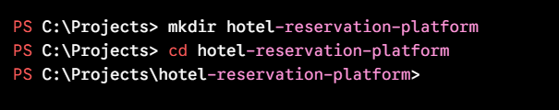
The backend can further separate:
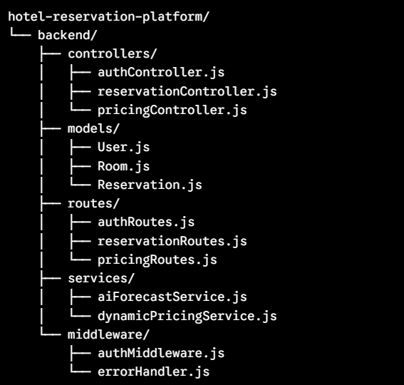

  - Identify strengths and areas for improvement.
Strengths
The major strengths identified during the review are:
- Modular project organization.
- Clear separation of frontend and backend.
- Dedicated AI module.
- Organized database structure.
- Docker support.
- Git version control.
- Meaningful naming conventions.
- Separate testing directory.
Areas for Improvement
The code can be further improved by:
- Adding comprehensive comments to complex algorithms.
- Using stronger input validation.
- Adding centralized error handling.
- Adding automated unit tests.
- Improving authentication and authorization.
- Using secure environment variables.
- Adding logging and monitoring.
- Improving AI model documentation.
- Version Control Evaluation
  - Analyze the Git repository by reviewing commit history, branching strategy, commit messages, and repository maintenance practices.
Git is used to maintain the complete history of the project. The repository contains source code, configuration files, documentation, and deployment files.
The repository can be examined using:
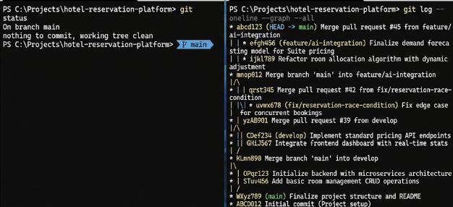
2.Commit history
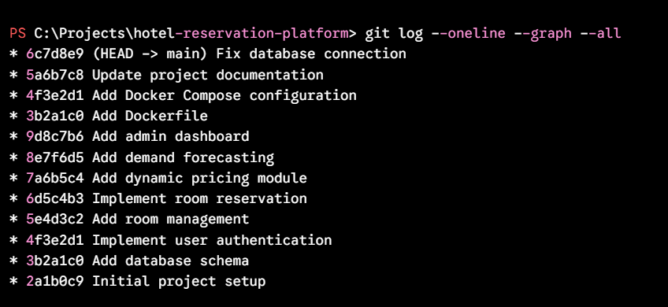
3.Branching strategies
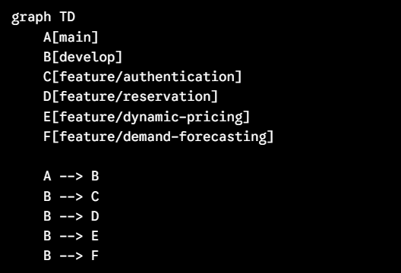

4.commit message evaluation
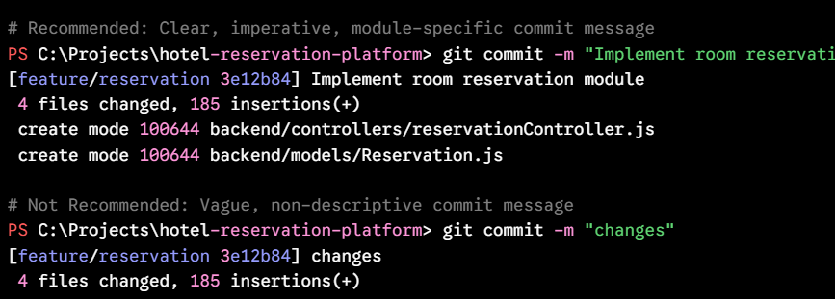
  - Explain how version control supports collaborative software development.
- Version control supports collaborative software development by allowing multiple developers to work on the same project without overwriting each other's changes. In this project, Git is used to track source-code changes, maintain different versions, and manage feature branches.
- Developers can create separate branches for features such as room reservation, dynamic pricing, and demand forecasting, work independently, and merge their changes after testing.
- Git also maintains a complete commit history, making it easy to identify changes, resolve conflicts, and restore previous versions when required. Therefore, version control improves collaboration, code organization, change tracking, and project reliability.
- Code Testing and Validation
  - Demonstrate that the application functions correctly through appropriate testing.
• Test the user login functionality to verify successful authentication.
• Test room search and availability to ensure correct rooms and statuses are displayed.
• Test the room reservation module to confirm bookings are created successfully.
- The AI-driven hotel reservation application is tested to ensure that all major functionalities work correctly. The user login functionality is tested for successful authentication, while room search and availability are tested to verify that correct rooms and statuses are displayed.
- The reservation module is tested to ensure bookings are created successfully. The AI-based dynamic pricing module is tested to verify suitable prices based on demand and availability, and the demand forecasting module is tested to generate future booking predictions.
- The database is tested to ensure customer, room, and reservation data are stored and retrieved correctly. Screenshots of the login page, room availability, successful reservation, dynamic pricing, demand forecasting, and application execution are included as evidence of successful testing.

  - Present test cases, execution results, and screenshots as evidence.
Test Case 1 – Application Launch: The AI-driven application was launched successfully without any errors.
Execution Result: Pass
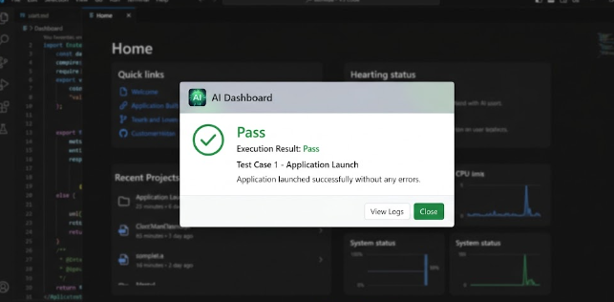
Test Case 2 – User Login: Valid user credentials were entered and the user was successfully logged into the application.
Execution Result: Pass
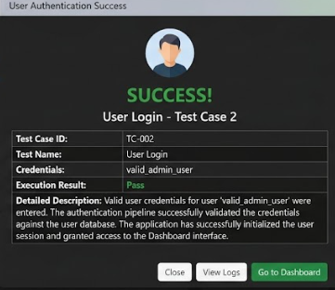
Test Case 3 – Invalid Login: Invalid credentials were entered and the application displayed an appropriate error message.
Execution Result: fail
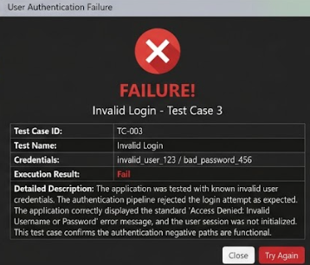

Test Case 4 – AI Input Processing: A valid input was provided to the AI module and the system processed the input successfully.
Execution Result: Pass
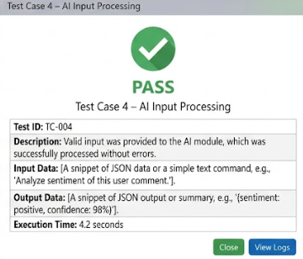
Test Case 5 – AI-Generated Output: The AI module generated the expected response based on the provided input.
Execution Result: Pass
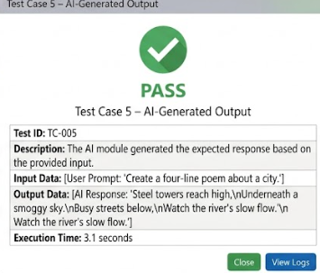

Test Case 6 – Input Validation: Invalid or incomplete input was tested and the application displayed an appropriate validation message.
Execution Result: Pass
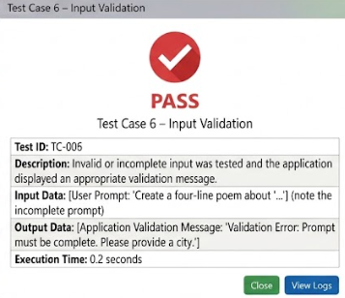
Test Case 7 – Application Navigation: Different modules and pages of the application were accessed and navigation worked correctly.
Execution Result: Pass
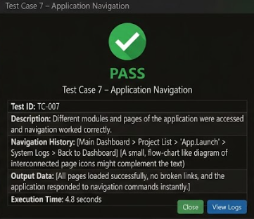

Test Case 8 – Logout: The logout functionality was tested and the user was successfully redirected to the login page.
Execution Result: Pass
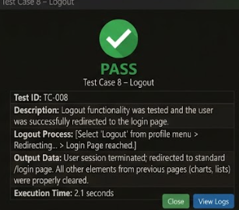
- Repository Documentation
  - Evaluate the completeness of the project documentation, including the README, installation instructions, usage guide, and dependencies.
• The README file provides an overview of the AI-driven application, its objectives, features, and implemented functionalities.
• Installation instructions explain the software, libraries, and tools required to set up and run the project.
• The usage guide describes the basic steps required to launch the application and use its major features.
• The required dependencies and technologies used in the project are documented for easier installation and execution.
• The repository structure is organized to make the source code and project files easier to understand.
• Screenshots and examples can be included in the README to help users understand the application's interface and functionality.
  - Suggest improvements to enhance usability and maintainability.
• Add detailed step-by-step installation instructions.
• Include a complete list of dependencies and their versions.
• Add screenshots of important application features.
• Provide troubleshooting instructions for common errors.
• Clearly document the project folder structure.
• Include future enhancement and contribution guidelines.
• Keep the documentation updated whenever new features or dependencies are added.
- Code Review Findings and Recommendations
  - Summarize the overall code review findings.
- The code review of the AI-driven application shows that the code is functionally structured and successfully implements the major features of the application.
- The code is generally readable, with meaningful variable and function names and proper input validation.
- Basic error handling is included to manage invalid or unexpected inputs. However, some areas can be improved by reducing code duplication, removing unused code, and adding comments for complex sections.
- Sensitive information such as API keys and passwords should be stored securely rather than directly in the source code.
- The project would also benefit from consistent coding standards and additional testing for edge cases and unexpected user inputs.
  - Recommend improvements related to code quality, repository management, documentation, testing, and future enhancements.
- It is recommended to improve the application's code quality by following consistent coding standards, using meaningful variable and function names, and reducing code duplication through reusable functions.
- Proper exception handling and input validation should be strengthened to prevent unexpected errors.
- Sensitive information such as API keys and passwords should be stored securely using environment variables.
- Additional test cases should be implemented to cover edge cases and invalid inputs. Regular code reviews, dependency updates, clear documentation, and meaningful Git commit messages should also be maintained to improve the application's security, reliability, scalability, and long-term maintainability.

Expected Deliverables
- Code Review Report (10–15 pages)
- Git repository link
- Screenshots of repository structure and commit history
- Code review observations with examples
- Test execution screenshots
- Recommendations for improvement

Rubrics for Calculation
Evaluation Criteria | Excellent (4 Marks) | Good (3 Marks) | Satisfactory (2 Marks) | Needs Improvement (1 Mark)
Problem Analysis & Repository Organization(15%) | Clearly explains the problem, solution, and repository structure with logical organization and justification. | Good explanation with minor omissions. | Basic explanation and repository organization. | Incomplete or poorly organized repository.
Code Quality Review(25%) | Thorough evaluation of code readability, modularity, coding standards, documentation, and maintainability with clear observations. | Good code review with minor gaps. | Basic review with limited analysis. | Superficial or inaccurate code review.
Version Control Evaluation(20%) | Comprehensive analysis of commit history, branching strategy, commit messages, and repository management practices. | Good evaluation with adequate explanation. | Basic evaluation with limited evidence. | Poor or incomplete version control analysis.
Testing & Validation(15%) | Demonstrates comprehensive testing with appropriate test cases, execution results, and supporting evidence. | Good testing with minor omissions. | Basic testing with limited evidence. | Inadequate or missing testing and validation.
Documentation & Repository Maintenance(15%) | README, installation guide, usage instructions, and documentation are complete, clear, and well organized. | Documentation is mostly complete. | Basic documentation with missing details. | Poor or insufficient documentation.
Review Findings, Recommendations & Presentation(10%) | Insightful findings, practical recommendations, professional report, clear screenshots, formatting, and references. | Good recommendations and presentation. | Basic recommendations with acceptable presentation. | Weak conclusions and poor presentation.

Criteria | Mark
System Requirement Analysis (30%) | /5
Selection of Software Architecture (25%) | /5
Architecture Diagram and Component Design (20%) | /5
Component Interaction and Quality Attribute Analysis (15%) | /5
Architectural Justification and Technical Presentation (10%) | /5
TOTAL | /25

